**CS Connection**

**Florida State University**

Software Requirements Specification

December 2nd, 2015

Wacky-Waving-Tube-men:

Nate Craver

Drew Smith

Rafael Aguilera

**Table of Contents**

*I. Introduction...........................................................................................................................................................3*

* 1. *Purpose ....................................................................................................................................3*
  2. *Scope of the System Specified ........................................................................................3*
  3. *Definitions, Acronyms, and Abbreviations ...............................................................4*
  4. *References to Supporting Documents.........................................................................4*
  5. *Overview………………….........................................................................................................4*

*II. General Description ..........................................................................................................................................5*

* 1. *Product Perspective.............................................................................................................5*
  2. *Product Functions ................................................................................................................5*
  3. *User Characteristics.............................................................................................................6*
  4. *General Constraints ............................................................................................................7*
  5. *Assumptions and Dependences......................................................................................7*

*III. Functional Requirements...............................................................................................................................8*

*IV. Non-functional Requirements......................................................................................................................8*

*V. System Architecture...........................................................................................................................................9*

*VI. System Model......................................................................................................................................................10*

*VII. Appendices..........................................................................................................................................................10*

1. *Data Dictionary.......................................................................................................................11*
   * 1. *Actor Descriptions...............................................................................................12*
     2. *Use Case Descriptions........................................................................................13*
     3. *Class Descriptions................................................................................................14*
     4. *Sequential Diagram…........................................................................................14*

**I. Introduction**

This section gives a scope description and overview of everything included in this SRS document. Also, the purpose for this document is described and a list of abbreviations and definitions is provided.

**i. Purpose**

The purpose of this document is to present a detailed description of a Computer Science Internship Web-Application for the Florida State University. It will explain the purpose and features of the system, the interfaces of the system, what the system will do, the constraints under which it must operate and how the system will react to external stimuli.

**ii. Scope of the System Specified**

CS Connect strives to ensure that all internships offered are administered under standardized conditions that are accurate, fair, and secure, while providing examinees with the utmost level of student-friendly service that allows each to take advantage of internship opportunities.

System Administrators are able to login to the system with a valid username and password to perform specific admin operations. Administrators have access to all facets of the website including the UI, database, and its entries. They can access all parts of the system and can also take on the privileges of student and company roles. Administrators can add, edit, and delete any entry within the system at will.

Students can register with CS Connection with their basic information and a valid FSUID. Once the registration process is complete, the student may browse through all internships posted by companies. Students may update, edit, or delete any of their information at any time.

Companies can register with CS Connection with their basic information. Once the registration process is complete, companies can post ads containing information about their company and internship details in which students can directly interact with. Companies may browse through all students in the system and directly reach out to them concerning internship opportunities. Companies may update, edit, or delete any of their information at any time.

**iii. Definitions, Acronyms, and Abbreviations**

|  |  |
| --- | --- |
| **Term** | **Definition, Acronym, or Abbreviation** |

**iv. References to Supporting Documents**

* **Object Oriented Modeling and Design with UML-Michael Blaha, James Rambaugh**
* **Software Engineering, Seventh Edition, Ian Sommerville**
* **W3schools.com**
* **BootStrap.com – Background Template**
* **MYSQL.com – Local Server Management / Configuration**
* **Database Management Systems - Navathe**

**v. Overview of rest of SRS**

Section II of the SRS describes the product in more detail. Section III provides a complete list of the functional requirements of the intended system. Section IV provides the non-functional requirements. Section V shows the class diagram, and Section VI the use case diagram. The appendices appear next.

**II. General Description**

**i. Product Perspective**

The SRS is a web-based system in which students and companies can interact with each other relating to possible internship opportunities. Students may list any accomplishments, achievements, or reasons why they are fit for a particular internship. They may also upload a resume where companies can browse through various students for their choosing. Companies may also list information about their corporation and what they have to offer, as far as job titles, salaries, and possible locations. CS Connect has the purpose to simply make a more efficient way for students to get involved with internships that companies have to offer on a simple web-platform.

Company

Admin

Database

Student List

Company List

CS Connect

Student

**ii. Product Functions**

**System Administrators:**

* Login to the system with valid username and password.
* Having access to all facets of the website.
* Access all parts of the system for testing purposes.
* Can take on the privileges of Student, Company, and Admin roles.
* Add, edit, and delete any tuples within the database.
* Browse and search users and posts within the system.
* Contact students or companies personally.
* Update the UI and system software.

**Student:**

* + Login to the System using their FSUID and password.
  + Register to join CS Connect.
  + Upload, edit, and delete their resumes.
  + Create posts where companies can view their basic and educational information.
  + Edit posts that they have already currently uploaded to the webpage.
  + Delete posts that they have already currently uploaded to the webpage.
  + Search various companies that are offering internships.
  + Receive Email alerts of new internship postings.
  + Delete and edit their account.

**Company:**

* Register for CS Connection
* Login into the System with valid username and password.
* Create, update, edit, or delete any personal posts.
* Search and browse students within the system to gather information.
* Contact students personally.
* Update personal information.
* Delete account.
* Save students that interest them.

**iii. User Characteristics**

There are three types of users that interact with the system, which are the System Administrators, the Students, and the Companies. Each of these three types of users has different use of the system so each possesses their own characteristics.

The System Administrator is responsible for maintaining the software, database, operating system, network, and configuration. Can have permissions to access all parts of the system for testing purposes. System Administrator is also fully responsible for the functionality of the system and its security.

A company can login into the system and browse and search for students for which they are interested in. They may select students that meet their criteria and may contact them via email or phone. They may also update any of their job postings at any time due to changes for the position.

A student can login into the system and browse and search for a company for which they are interested in. They may select a company to find more information about them in which they can then contact directly via email or phone.

**iv. General Constraints**

There are currently no constraints for the system.

**v. Assumption, and Dependences**

1. Students and companies will have access to email and Internet.

2. Students and companies will have a basic understanding of how to use a computer and access URLs over the Internet.

3. Students are responsible for contacting companies regarding possible internships personally.

4. Students or companies have the proper contact information.

5. To email a student registered you need to append @my.fsu.edu after their FSUID.

6. All users are protected through an encrypted system.

**III. Functional Requirements**

1. Companies will set the date and location of the possible internship available.
2. Companies must be registered to access CS Connect.
3. Companies can create multiple posts and keep track of their activity.
4. Companies must have a valid contact.
5. Companies must keep their posts up-to-date or will be removed by admin.
6. Companies may change their password and account information.
7. Companies may edit or update any personal information.
8. Companies can add, edit, or delete any personal posts.
9. Companies can select students and contact them by using the students contact information.
10. Students can apply for multiple internships.
11. Only students who are registered may have access to CS Connect to view the possible internships.
12. Students must login to the system using their FSUID and unique password.
13. Students may change their password.
14. There must be a mechanism to recover a lost password.
15. Students may edit or update any personal information.
16. Students can choose a company that they desire and contact them directly.

**IV. Non-functional Requirements**

1. All personal information is accurate.
2. Student resumes are truthful and readable.
3. Companies are clear on the internship position.
4. Companies are truthfully looking for student internships.

**V. System Architecture**

This section presents a high-level overview of the anticipated system architecture using a class diagram. It shows the fundamental objects/classes that must be modeled with the system to satisfy its requirements. Each class on the diagram must include the attributes related to the class. All the relationships between classes and their multiplicity must be shown on the class diagram. The classes specified in this document only are those directly derived from the application domain.

Home Page:

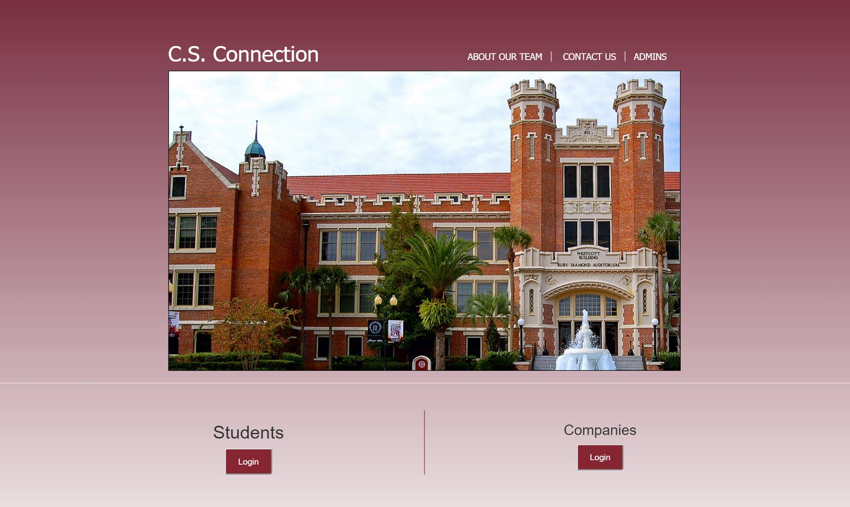

Company Profile Page:

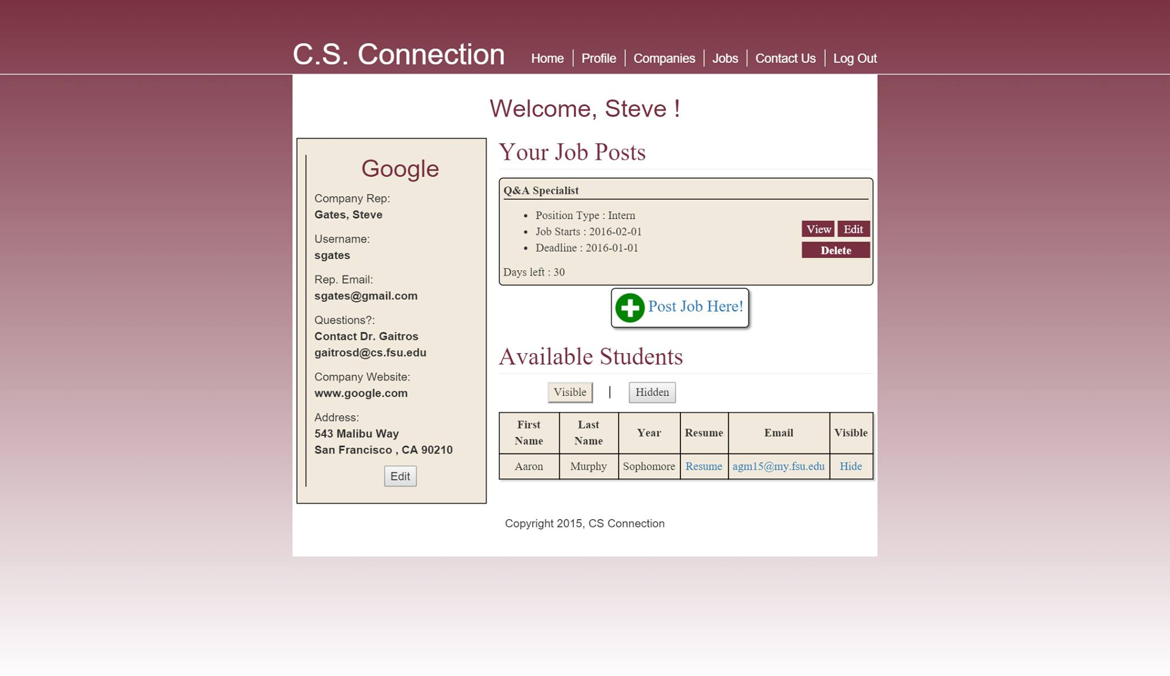

Student Profile Page:

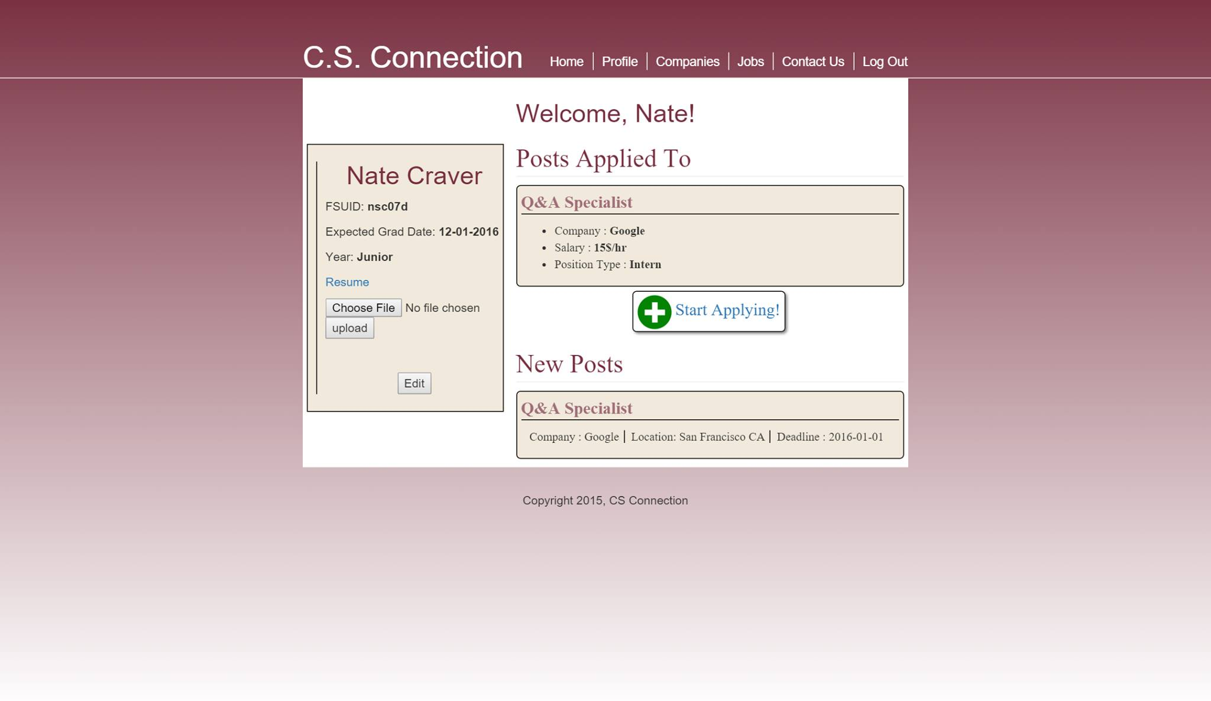

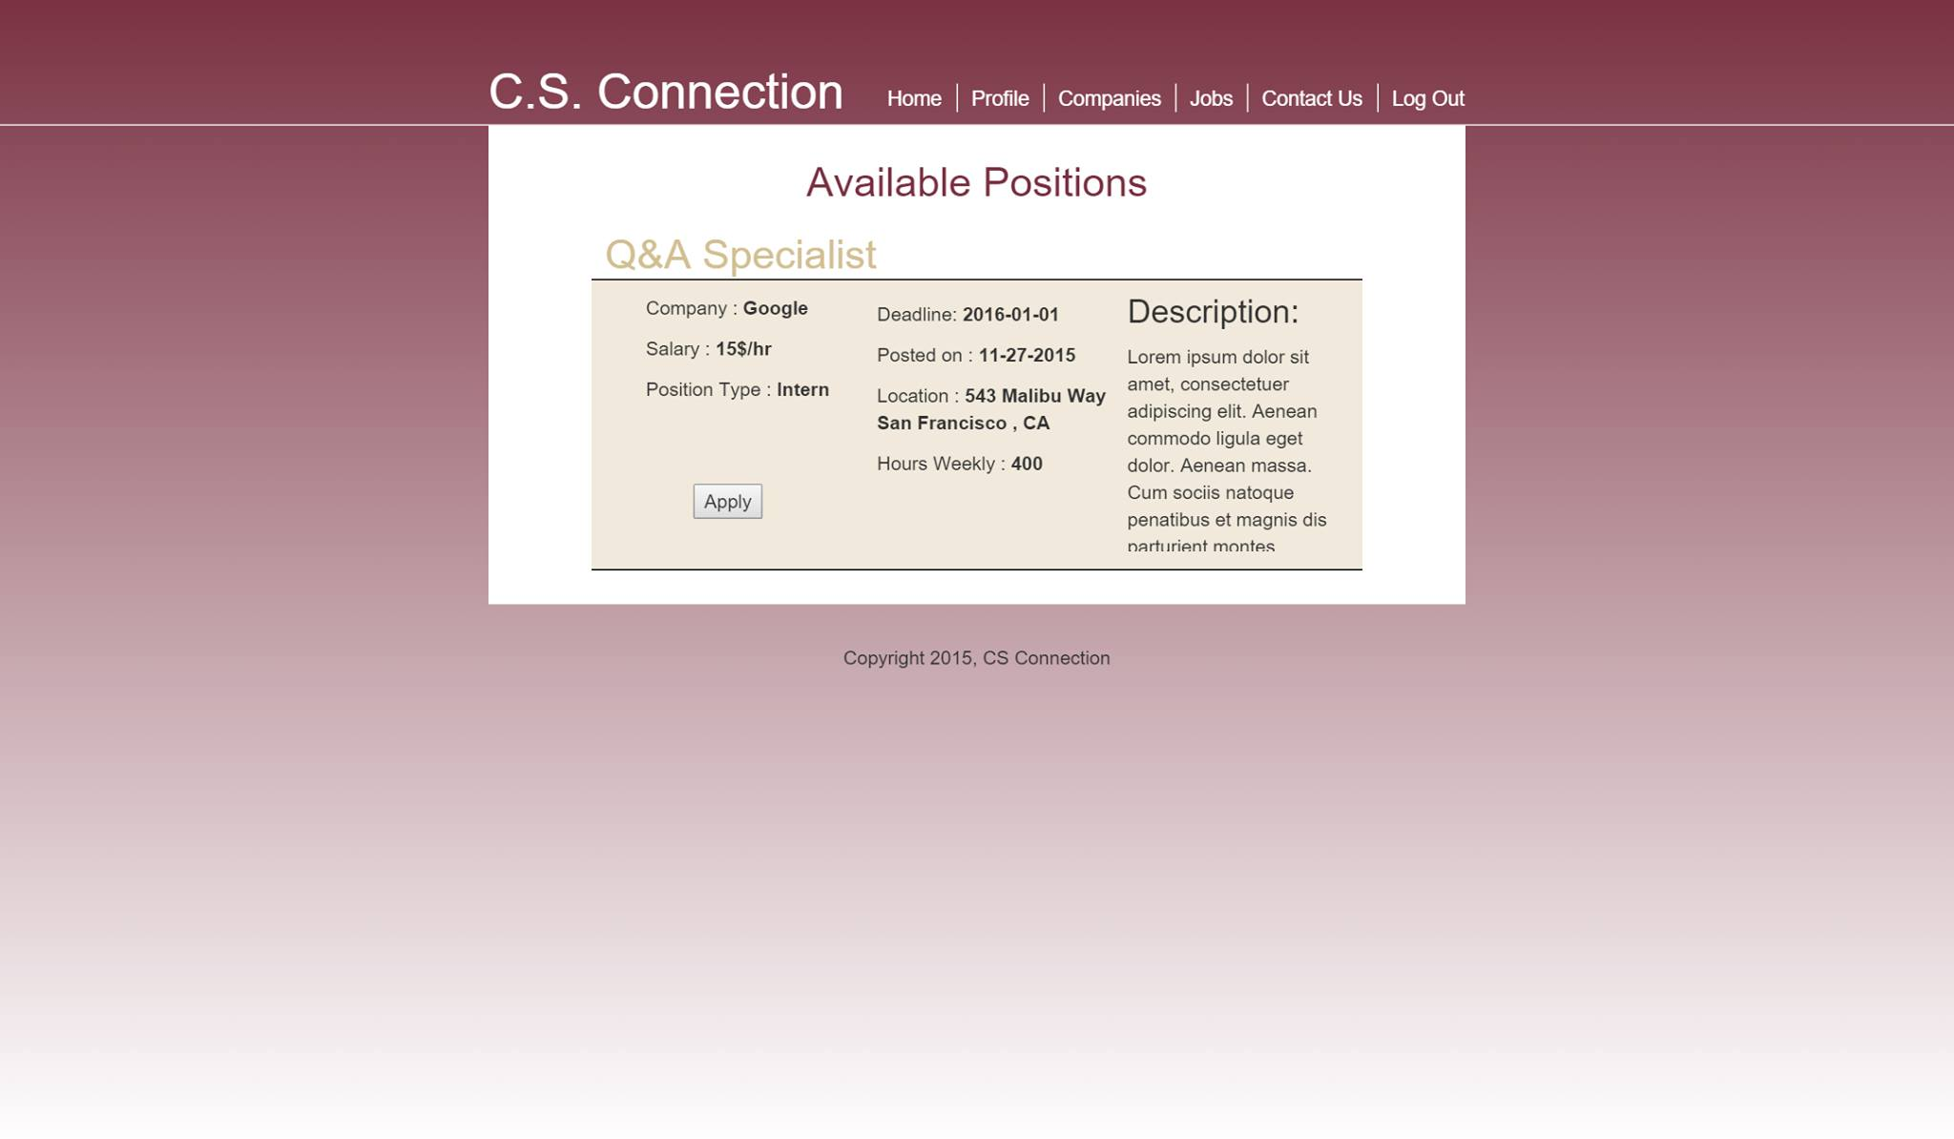Company Job Postings:

USE CASE DIAGRAM:



**VI. System Model**

This section presents the use case diagram for the system under development. The use case diagram should be a complete version containing all the use cases needed to describe the functionality to be developed.

CLASS DIAGRAM:



**VII. Appendices**

1. **Data Dictionary**
2. **Actor Descriptions**

**Student Actor: Students must be enrolled students at the Florida State University within the Computer Science Department. Students must register within the system, which will enable companies to view their information and resume.**

**Company Actor: Companies are allowed to access the system globally. They are able to register and directly associate with students who are seeking internship opportunities. They are in complete control of their basic and private information, which can be edited or deleted at any desired time.**

**System Administrator Actor: Administrators are in complete control of the system. Administrators control the system design, UI, and database. Administrators can add, edit, search, browse or delete any user within the system.**

1. **Use Case Descriptions**

**Register: Companies and students can both register for the file. They must provide the following:**

* **First Name**
* **Last Name**
* **Address**
* **Phone Number**
* **Email**
* **Student: Resume**
* **Company: Job Description**

**Login: Companies and Students who have previously registered for the system are able to login within their personal credentials, which are embedded within the systems database.**

**Session: A session within the system upon login includes the following:**

* **Searching and browsing for companies or students**
* **Companies: Creating job listings**
* **Students: Accessing activity from interested companies**
* **Accessing page links: Home, About Us, Contact Us**

**Delete: Students and Companies can delete any personal information.**

**Edit: Students and Companies can edit any personal information.**

**Search: Students can search for companies by inserting company names within the search bar. Companies: Companies can search through students who have registered within the system. They may insert specific criteria to filter their results.**

**Browse: Students can browse through companies within the Student home page where the most recent Company activity has occurred. Companies: Companies can browse through students who have registered within the system. The most recent students who have registered for the system will appear at the top of their Company Profile page.**

**Sequence Diagram/ Class Description:**

